Case-Study: UDP Ping Pong Attack

Title: Simulating and Mitigating a UDP Ping Pong Attack in a Virtualized Network

Student name: Anurag Deepak Karmakar
Date of Completion: March 12, 2025

Executive Summary
This case study demonstrates a UDP Ping Pong attack, a simple yet dangerous network vulnerability where two hosts, usually a server and a user that are running UDP services continuously exchange packets, leading to network congestion and potential denial of service (DoS). In our simulation, an attacker sends one spoofed packet , tricking a server into blindly responding, which apparently flooded an innocent user with excessive traffic. This exploit can overload network resources, disrupt operations, and degrade system performance.

To reduce the risk of such attacks, organizations should block spoofed packets using firewall rules, implement rate limiting on UDP services to prevent excessive responses, and disable unnecessary UDP services to minimize exposure. Additionally, monitoring network traffic for unusual patterns can help detect and mitigate attacks early. By applying these security measures, businesses can protect their networks from UDP-based threats and improve overall cybersecurity resilience.

2. Attack Description
The UDP Ping Pong attack is an exploit that takes advantage of the connectionless nature of UDP, where two hosts using UDP services continuously exchange packets without validation. An attacker can amplify this effect by spoofing the source IP, leading to excessive traffic that congests the network and depletes system resources, potentially resulting in a Denial-of-Service (DoS) attack.

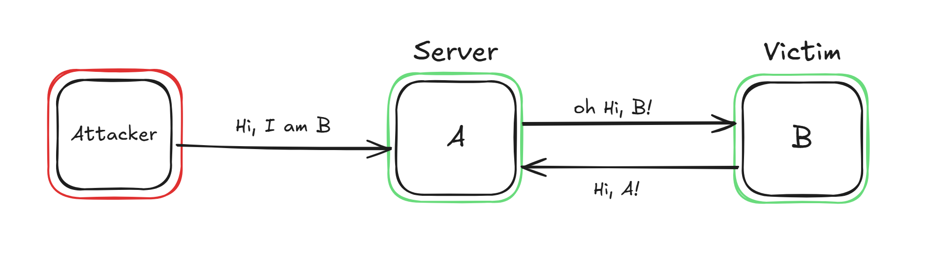

  - Network Topology
The simulation is conducted in a virtual environment with the following setup:
- Victim (10.9.0.5): A victim client that automatically responds to UDP packets.
- Server (10.9.0.2): A server that is set to reply automatically once a UDP packet is received.
- Attacker (10.9.0.25): Sends a spoofed UDP packet to initiate the attack.
Tools Used: Docker, Scapy, Socket, Python, Wireshark.
2.2 Vulnerabilities Exploited
The attack exploits the following vulnerabilities:
- Lack of connection verification in UDP: Since UDP does not establish a session, it processes and responds to packets without verifying the sender.
- Misconfigured UDP services: The server blindly responds to every request, making it susceptible to infinite response loops.

3. Experiments
This simulation uses three docker hosts running
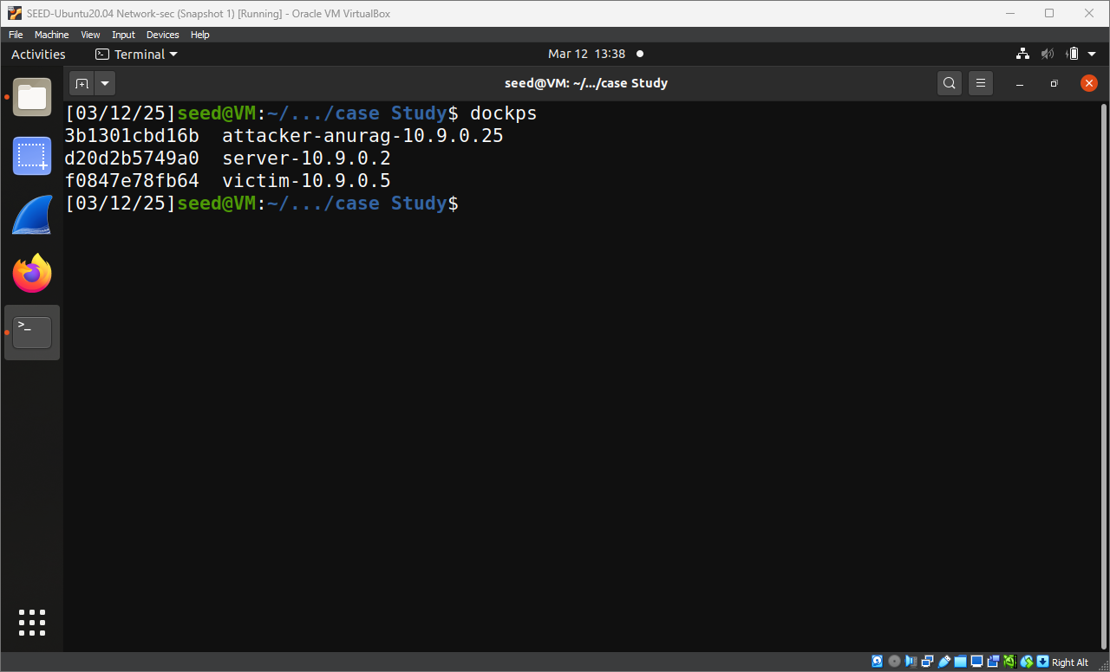
There are 3 python scripts, names are self-explanatory
- attack.py: used by the attack the send one single spoofed UDP packet
- server-listener.py: Acts as a server service on the server, listens for UDP packets and responds to them
- victim-listener.py: Acts as a client service on the user’s system to listen for UDP packets and respond to them.

The server and the victim(user) have almost same scripts running, just with different responses for the differences,
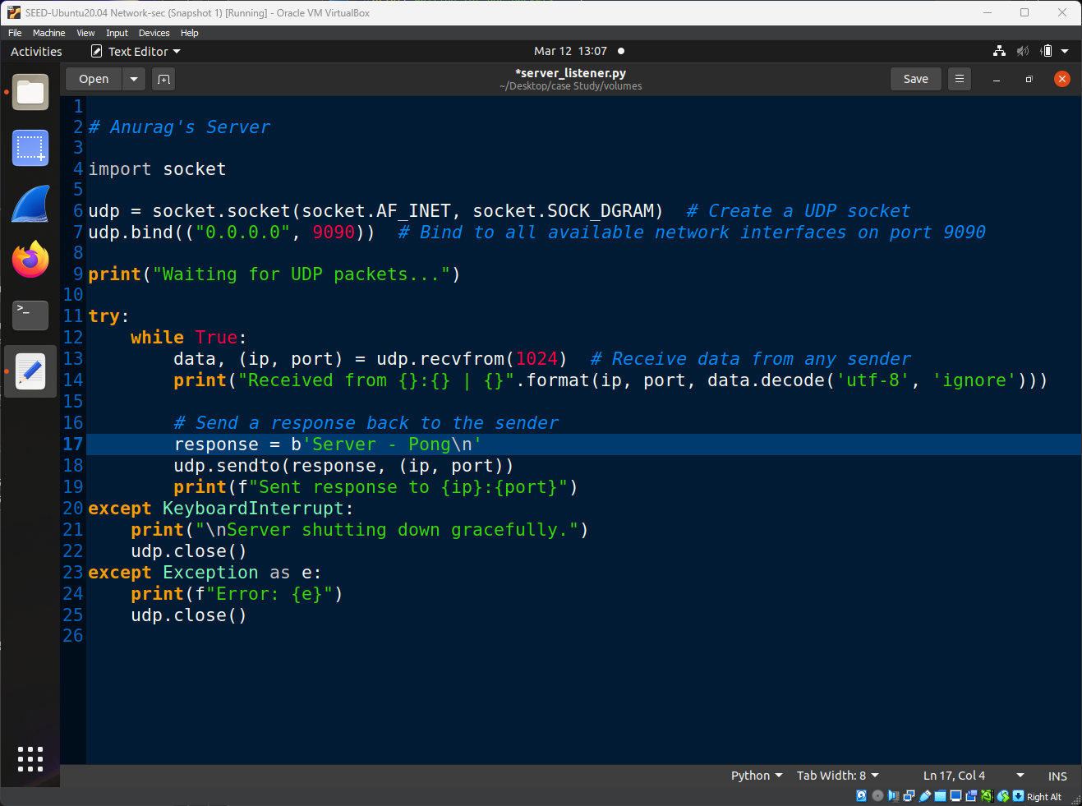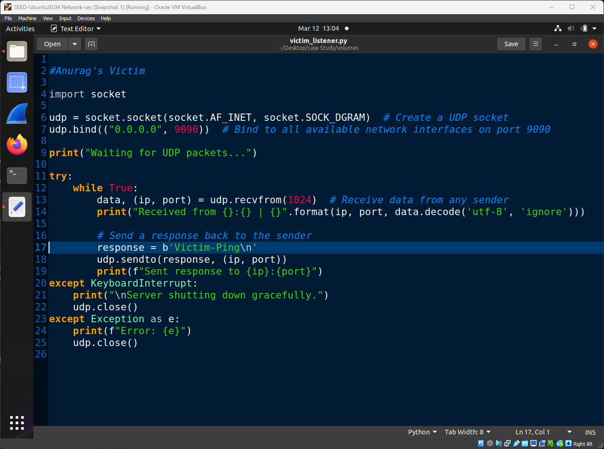
these scripts emulate a server and client for a certain service and are programmed to respond to UDP packets.

3.1 Server’s Role (10.9.0.2)
In real scenarios, because UDP is a connectionless protocol meaning it does not verify the sender before processing and responding to packets. Servers usually blindly respond to UDP packets automatically, and to replicate the same, I used this python script that acts as a server and uses socket to listen for UDP packets and reply “Server – Pong”. In this case, the server is programmed to respond to every received packet with a new packet, leading to an endless loop if another misconfigured service or a spoofed request is involved.
The python script on the server runs socket, a python library to handle communications, the script here is bound to port 9090 for this demonstration, waits until it receives a UDP packet on the same port. Once it receives a UDP packet it creates a UDP packet with the destination IP as the sender’s IP address with raw Data as ‘Server - Pong’

3.2 User’s Role (10.9.0.5)
For this simulation the User uses the same python script “Victim_Listener.py” as the server to listen for UDP packets and respond with “Victim-Ping” and here the user was not interacting with the server to begin with before the attacker made a move, user was just authorized to connect with the server, that’s it. The attacker spoofs their ip address and sends a packet to the server, and the server believes as if it was coming from the user and responds back to the user since the user’s system responds, back to the server it lead to a chain reaction on responses where eventually, the user experiences network congestion and potential denial of service (DoS) because, their device is flooded with unexpected UDP responses. Their bandwidth is consumed, slowing down or disrupting their normal network activity. Their CPU usage may spike if the system tries to process the unexpected packets.
The python script on the victim is almost identical as the server script it runs socket, a python library to handle communication, the script here is bound to port 9090 for this demonstration, waits until it receives a UDP packet on the same port. Once it receives a UDP packet it creates a UDP packet with the destination IP as the sender’s IP address with raw Data as ‘Victim-Ping’

3.3 Attacker’s Role (10.9.0.21)
The server and user were not communicating, but the attacker initiates a communication between them by, sending a single spoofed UDP packet, using a python script “attack.py” where the source IP address is to be seen as the user by the server, making the server to respond back to the actual user and since, this is the first UDP packet they receive the user’s system responds back leading to a chain reaction of responses flooding the user by the server’s responses and eventually lead to a denial-of-service from the server. For this simulation I have this python script below that uses scapy to craft a spoofed packet and send it to the server. The packet has a raw data payload “Anurag’s attack”. So, when the connection is intercepted by any of the surveillance tools, (I have used Wireshark) it shows which packet was sent by the attacker and

4. Attack Impact and Evidence
The image below shows the attack packet with a raw payload for us to capture and as we can see this is the first UDP packet that Wireshark captured and apparently initiated a communication between 10.9.0.2 and 10.9.0.5. The source of the packet says 10.9.0.5 which seems to be as if the user was trying to communicate.

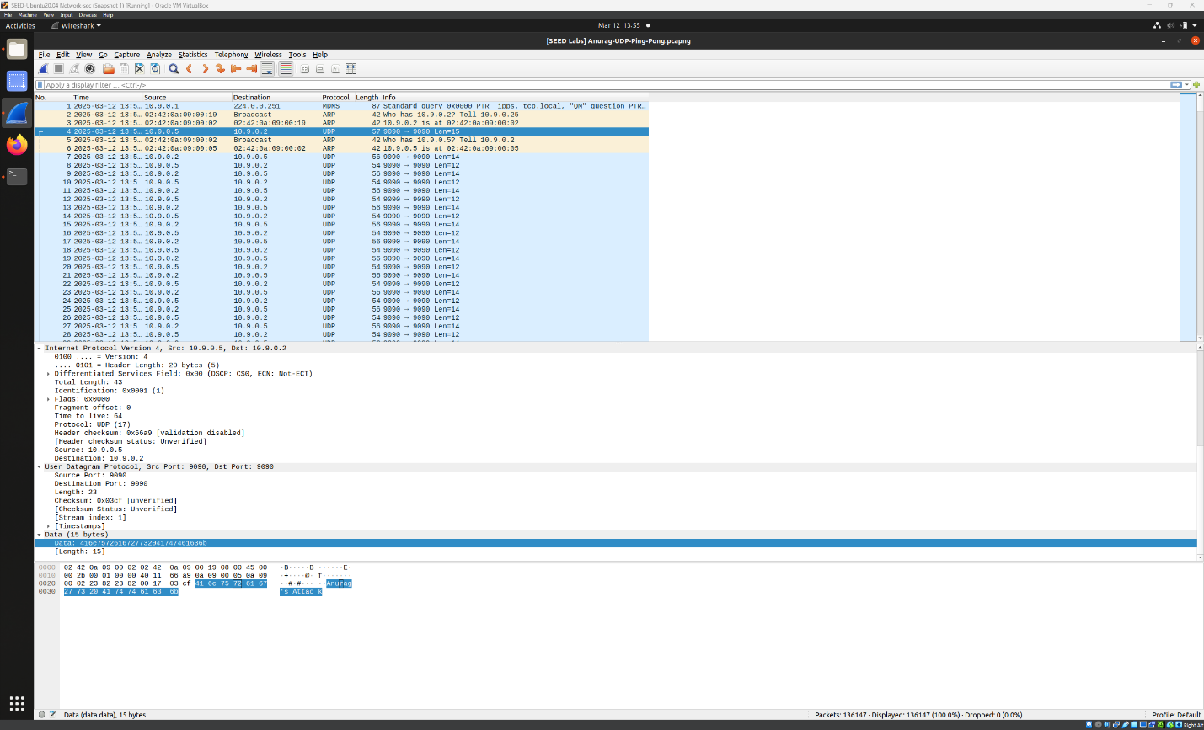
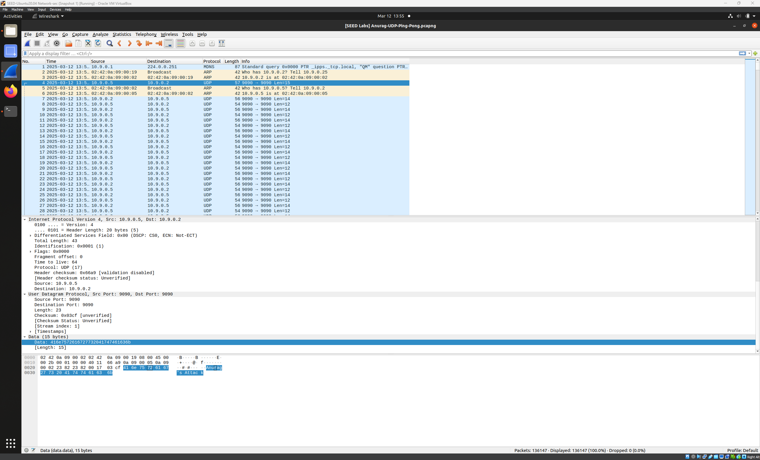
Now, the Server responds to this UDP packet as seen in the next image here now, for the all communications intercepted by Wireshark here has been between, 10.9.0.5 and 10.9.0.2, this implies that the ping pong attack has been initiated.

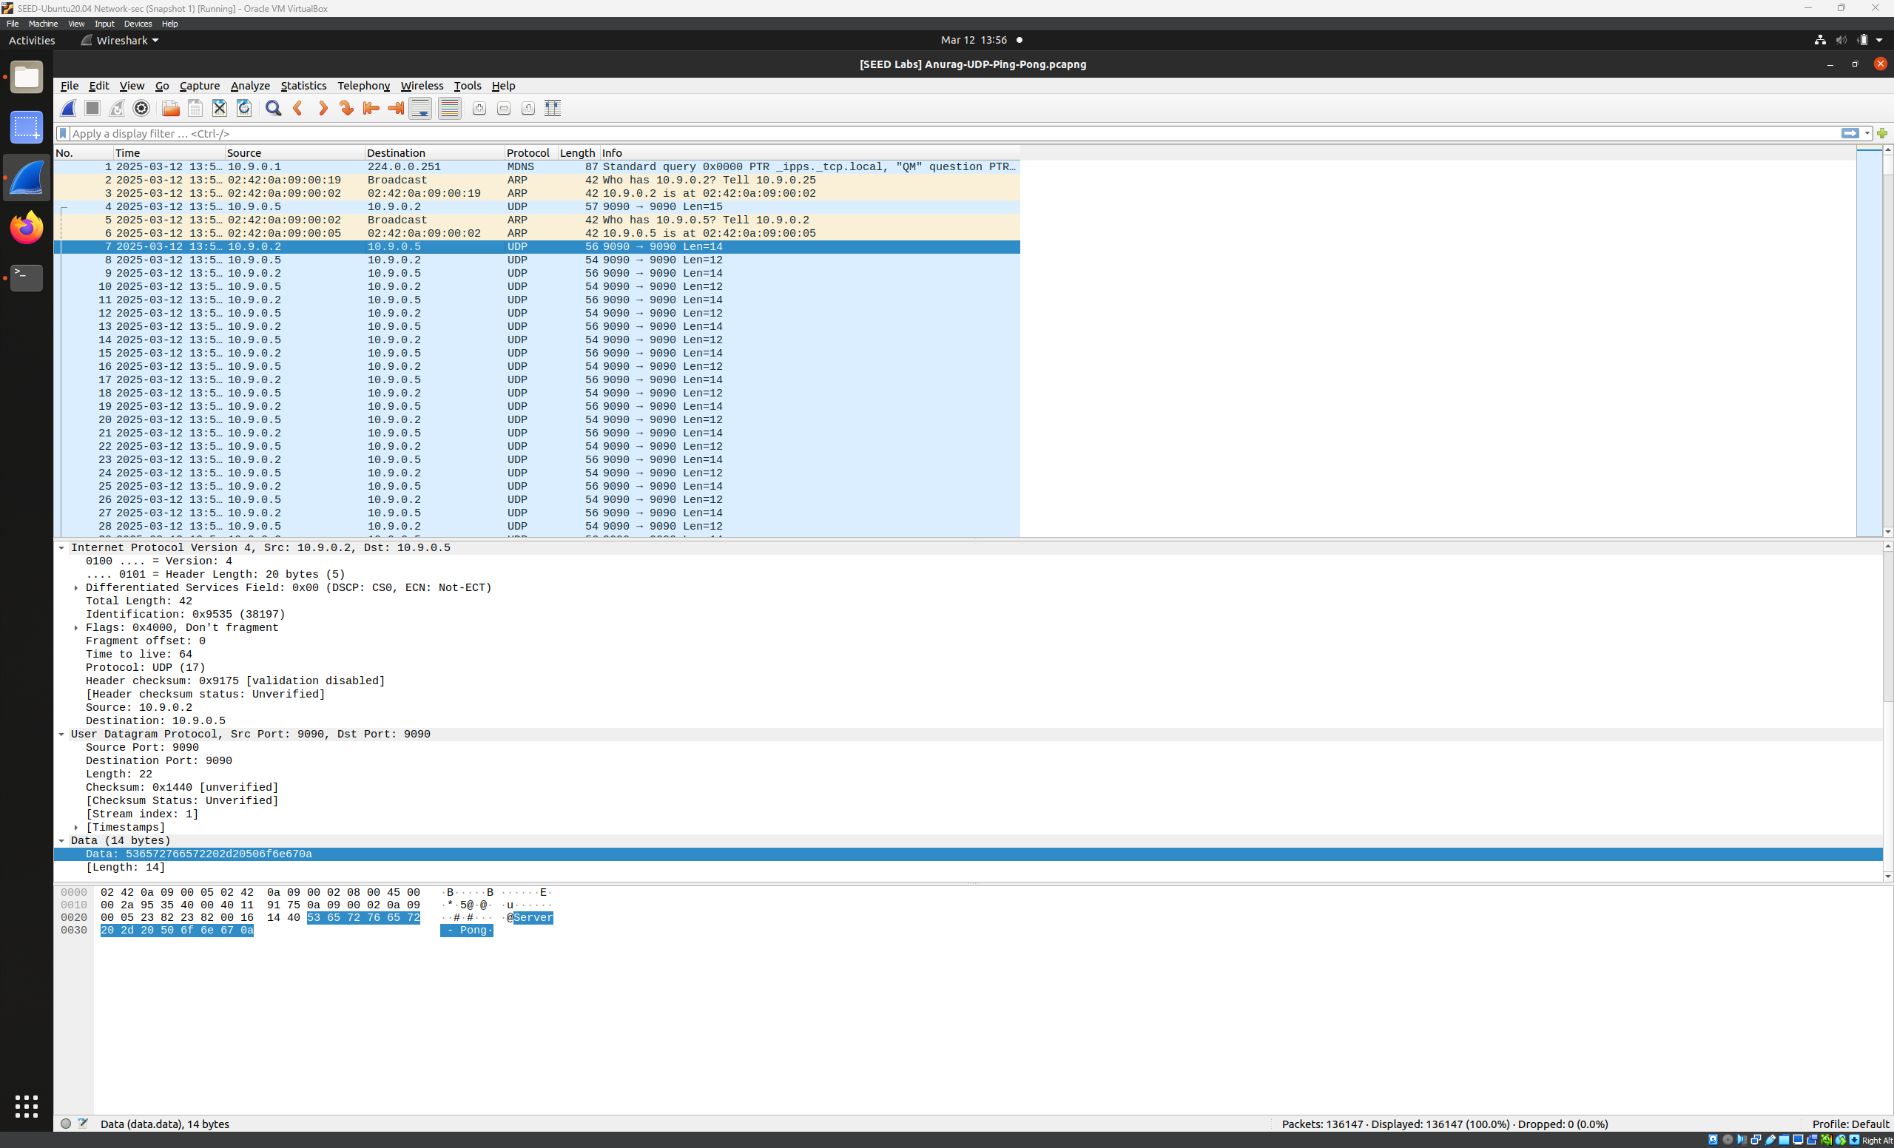

Following this the victim machine responds as shown in the images below,
The victim machine responds to the server saying ‘Victim-Ping’
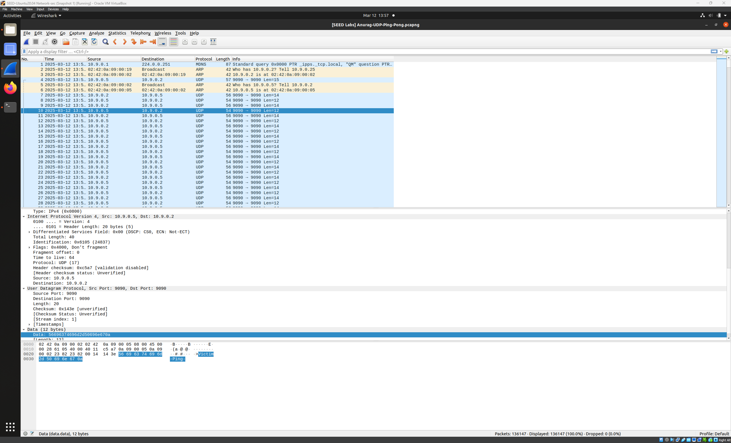
Now to this the server replies to the victims packet leading to an infinite loop of responses, overshooting CPU and Memory usage.
As we can see in the image below there have been more than 1300 packets while this attack has been running for barely 5 seconds.
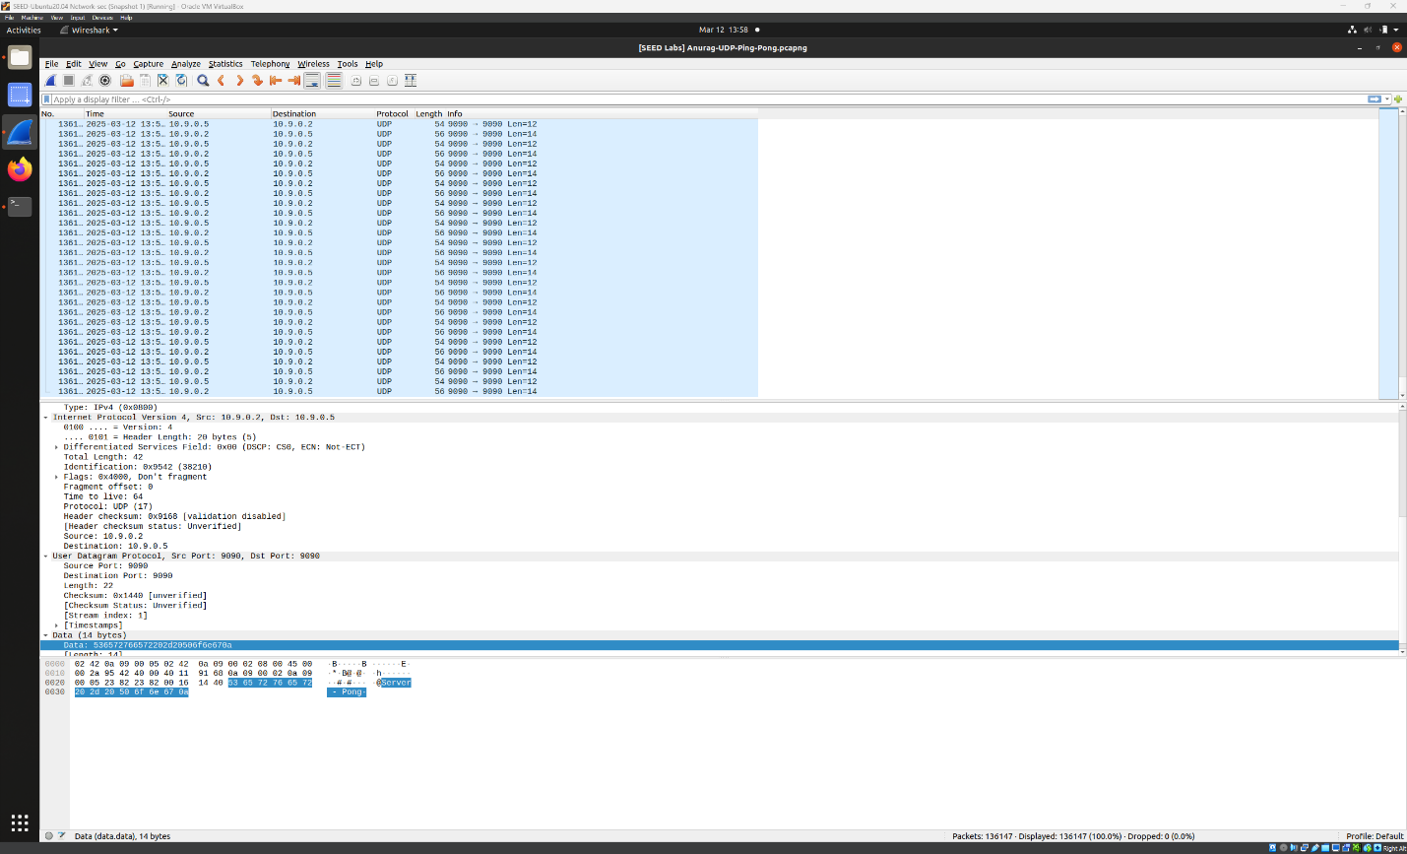

Below table has the output of the ‘top’ command in Linux, the top (table of processes) command shows a dynamic, real-time view of running processes and kernel-managed tasks in Linux. The command also provides a system information summary that shows resource utilization, including CPU and memory usage.
Server CPU and Memory usage before being attacked,

 | Before attack | After attack
Server | 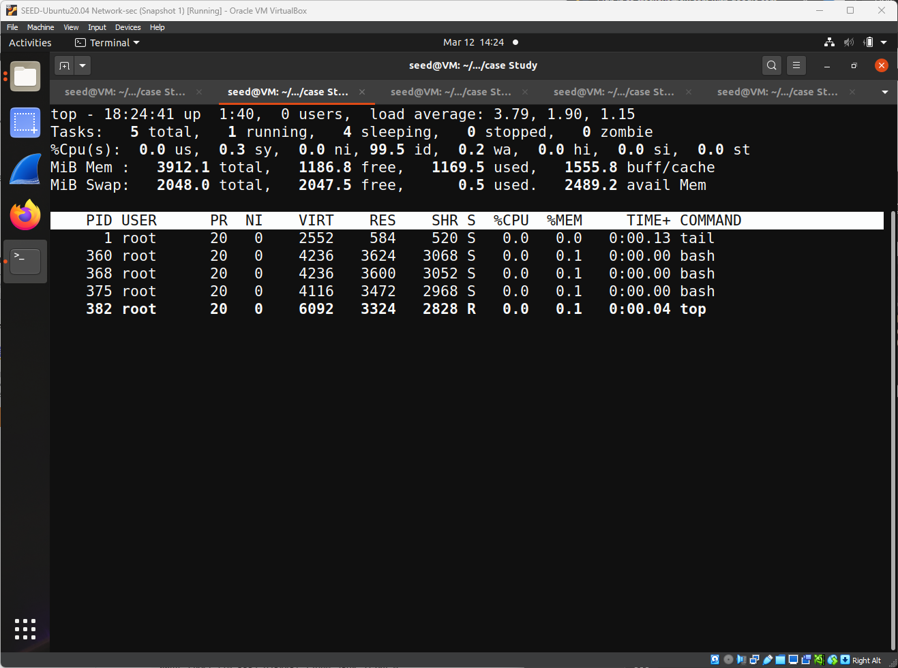 | 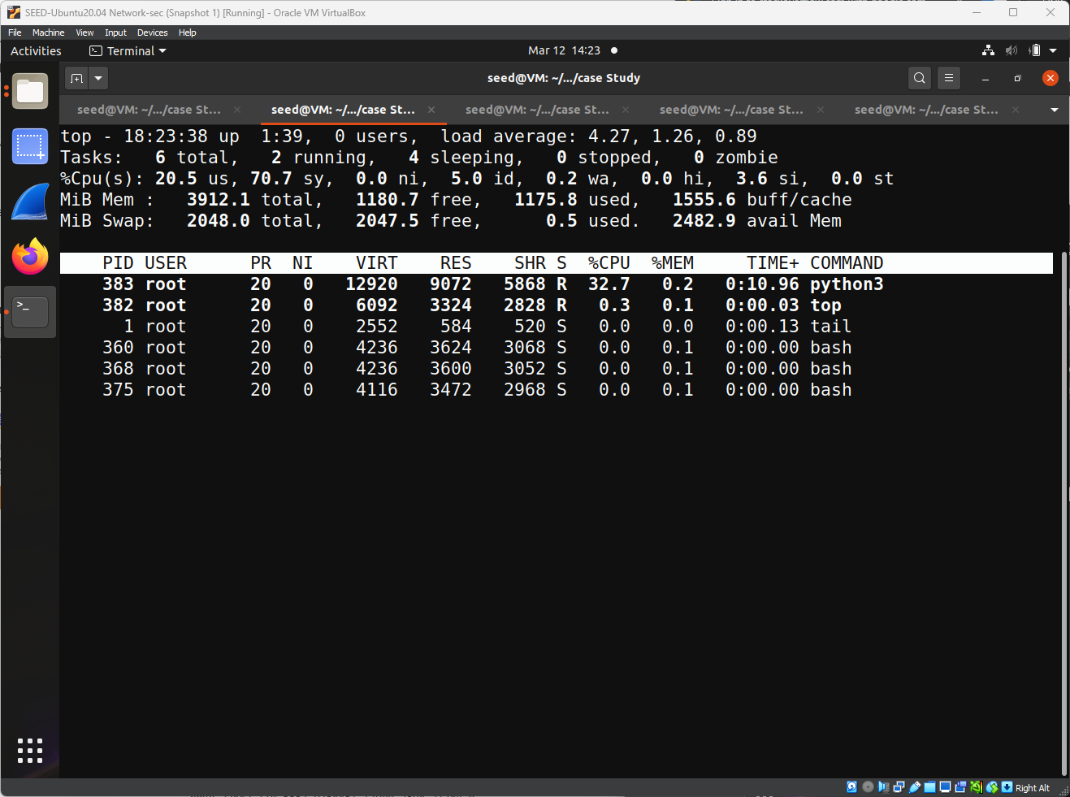
User | 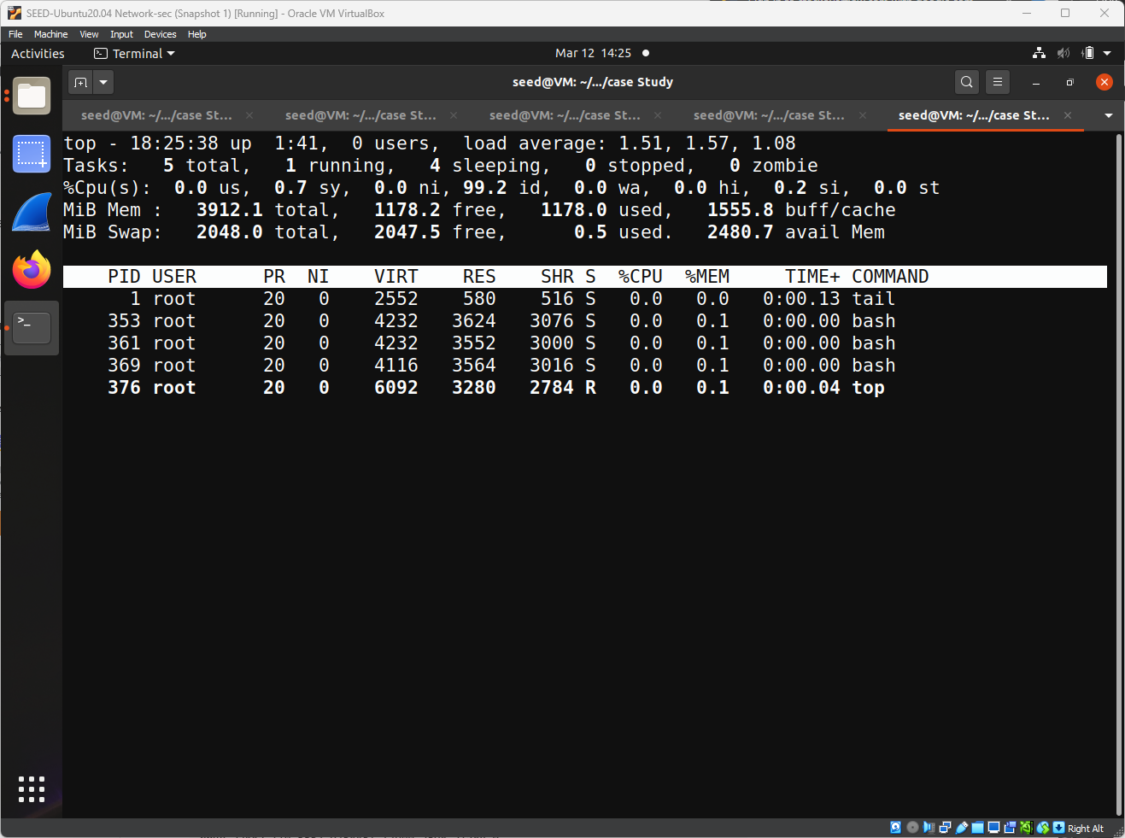 | 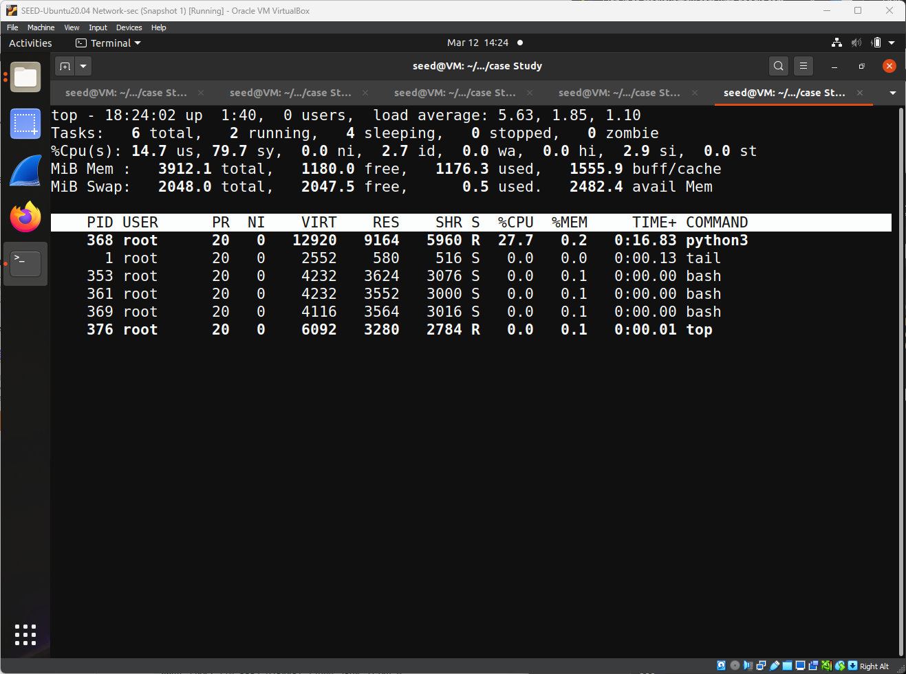

Since we are using python for listening and responding to UDP traffic. From the images we can see that the ‘python3’ command has 32.7% of CPU usage when under attack.
Similarly, for the user, the command ‘python3’ has a 27% of CPU usage on the user
All of this caused by one simple spoofed UDP packet, and from one zombie user.

5. Recommendations & Reflection
The UDP Ping Pong attack works because UDP does not verify the sender before responding to packets, allowing IP spoofing and uncontrolled traffic loops. It is particularly effective when servers blindly respond to any incoming UDP request, firewall rules are weak, and rate limiting is not enforced. However, the attack can be mitigated by blocking spoofed packets using firewall rules, implementing rate limits on UDP responses, disabling unnecessary UDP services, and monitoring network traffic for anomalies. These security measures help reduce the risk of exploitation and maintain network stability in an organizational environment.
5.1 Why the Attack Works
The UDP Ping Pong attack exploits UDP’s connectionless nature, where servers blindly respond to packets without verification. It is most effective when:
- Servers lack authentication and rate limiting.
- IP spoofing is possible due to weak network filtering.
- Misconfigured UDP services respond to any request.
  - When the Attack Might Fail
The attack is ineffective if security measures are in place, such as:
- Firewall rules blocking spoofed traffic.
- Rate limiting UDP responses.
- Authentication mechanisms verifying request sources.
- Network monitoring tools detecting unusual traffic.
  - Mitigation Strategies
- Prevent Spoofing: Use firewall rules to block forged packets.
- Limit UDP Responses: Implement rate limiting to reduce excessive replies.
- Disable Unused UDP Services: Turn off unnecessary services and enable access controls.
6. Case Reflection
Here in this case study, there were a number of assumptions made, such as, we assumed the attacker had prior knowledge of the victim’s IP, and the server lacked security mechanisms such as authentication and rate limiting. Another assumption was that the user was unaware of the attack, allowing the attack to complete with full impact.
Through this experiment, I gained a deeper understanding of UDP vulnerabilities, the importance of network monitoring, and how simple security measures can prevent large-scale disruptions. Additionally, this study reinforced Docker’s effectiveness in simulating real-world cybersecurity threats for hands-on learning and testing.

7. References
Wenliang Du, Internet Security: A Hands-on Approach 3rd Edition, ISBN-13: 978- 1733003957, ISBN-10: 9781733003964
8. Appendix
Python scripts used in this simulation are given below.

attack.py
# Anurag's Attack
from scapy.all import IP, UDP, Raw, send
# Spoofed source IP (Victim) and destination IP (Server)
VICTIM_IP = "10.9.0.5"
SERVER_IP = "10.9.0.2"
PORT = 9090
print(f"Starting UDP Ping-Pong attack: Spoofing {VICTIM_IP} -> {SERVER_IP}:{PORT}")
# Construct the spoofed UDP packet
spoofed_packet = IP(src=VICTIM_IP, dst=SERVER_IP) / UDP(dport=PORT, sport=PORT) / Raw(load="Anurag's Attack")
# Send the packet
send(spoofed_packet, verbose=True)
print("Packet sent!")

server-listener.py
# Anurag's Server
import socket
anurag = socket.socket(socket.AF_INET, socket.SOCK_DGRAM) # Create a UDP socket
anurag.bind(("0.0.0.0", 9090)) # Bind to all available network interfaces on port 9090
print("Waiting for UDP packets...")
try:
while True:
data, (ip, port) = anurag.recvfrom(1024) # Receive data from any sender
print("Received from {}:{} | {}".format(ip, port, data.decode('utf-8', 'ignore')))
# Send a response back to the sender
response = b'Server - Pong\n'
anurag.sendto(response, (ip, port))
print(f"Sent response to {ip}:{port}")
except KeyboardInterrupt:
print("\nServer shutting down gracefully.")
anurag.close()
except Exception as e:
print(f"Error: {e}")
anurag.close()
victim_listener.py
#Anurag's Victim
import socket
udp = socket.socket(socket.AF_INET, socket.SOCK_DGRAM) # Create a UDP socket
udp.bind(("0.0.0.0", 9090)) # Bind to all available network interfaces on port 9090
print("Waiting for UDP packets...")
try:
while True:
data, (ip, port) = udp.recvfrom(1024) # Receive data from any sender
print("Received from {}:{} | {}".format(ip, port, data.decode('utf-8', 'ignore')))
# Send a response back to the sender
anurag = b'Victim-Ping\n'
udp.sendto(anurag, (ip, port))
print(f"Sent response to {ip}:{port}")
except KeyboardInterrupt:
print("\nServer shutting down gracefully.")
udp.close()
except Exception as e:
print(f"Error: {e}")
udp.close()

